CINERESERVE

Solution Architecture
IDEATION PHASE • MOVIE TICKET BOOKING PLATFORM

1. Architecture objective
Use a modular MERN-style architecture with MVC-inspired separation so CineReserve can be developed and tested in manageable components. This is a proposed logical design; align it with the existing repository before making structural changes.

2. High-level architecture
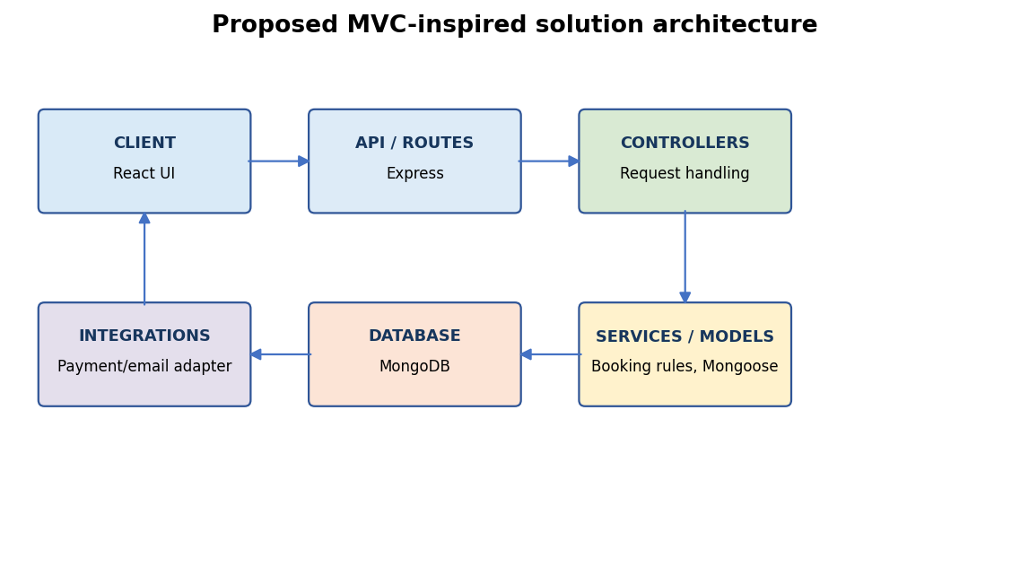

3. Layer responsibilities
Layer | Responsibilities | Example modules
Presentation — React | Pages, components, form state and accessible feedback. | Home, Movie Details, Seat Map, Checkout, My Bookings, Admin.
API routes — Express | Map HTTP endpoints and apply middleware. | /api/movies, /api/showtimes, /api/bookings, /api/auth.
Controllers | Translate requests into service calls and HTTP responses. | MovieController, BookingController, AuthController.
Services / domain logic | Enforce booking rules, seat holds, pricing and payment states. | BookingService, SeatHoldService, PricingService.
Models — Mongoose | Schemas, indexes, references and persistence. | User, Movie, Cinema, Showtime, Booking, Coupon.
Database — MongoDB | Persist users, catalogue, inventory and booking records. | Collections and indexes.
Integrations | Optional payment sandbox/provider, email and QR utilities. | Payment adapter, notification adapter, QR utility.

4. Proposed data model
Entity | Important fields | Relationship / note
User | _id, name, email, passwordHash, role | One user can have multiple bookings.
Movie | title, synopsis, language, genre, duration, posterUrl | A movie can have multiple showtimes.
Cinema | name, city, address, facilities | A cinema hosts multiple showtimes.
Showtime | movieId, cinemaId, startsAt, screen, basePrice | References one movie and cinema.
Seat inventory | showtimeId, seatLabel, status, holdExpiresAt, heldBy | Availability is scoped to a showtime.
Booking | userId, showtimeId, seatLabels, amountBreakdown, status, paymentStatus | Private record owned by a user.
Coupon | code, discountType, value, validFrom, validUntil, usageLimit | Validate eligibility server-side.

5. Example API contract
Method and endpoint | Purpose | Access
GET /api/movies | Browse/search movies. | Public
GET /api/movies/:movieId/showtimes | Find showtimes. | Public
GET /api/showtimes/:id/seats | Read seat availability. | Public or authenticated by product policy
POST /api/bookings/holds | Request temporary seat hold. | Authenticated
POST /api/bookings | Create booking after server validation. | Authenticated
GET /api/bookings/me | List current user's bookings. | Authenticated; own records only
GET /api/bookings/:id | Read booking details. | Owner or authorised admin
POST /api/payments/checkout | Start sandbox/provider checkout. | Authenticated
PATCH /api/admin/movies/:id | Update movie catalogue. | Admin only

6. Booking sequence and controls
Step | System action | Important control
1. Browse | Fetch catalogue and showtimes. | Validate query parameters.
2. Select seats | Submit requested seat labels. | Check seats belong to the selected showtime.
3. Hold | Create a short-lived seat hold. | Prevent overlapping holds; expire abandoned holds.
4. Price | Calculate price, fees and coupon. | Do not trust totals from the browser.
5. Checkout | Use provider sandbox or labelled simulation. | Track pending, success and failure distinctly.
6. Confirm | Revalidate hold and payment state. | Use atomic/transaction safeguards to prevent double-booking.
7. Issue ticket | Return booking ID and ticket view. | Authorise access and avoid exposing payment secrets.

7. Security and reliability controls
- Store password hashes, never plaintext passwords.
- Keep secrets in environment variables; do not commit .env.
- Validate and sanitise all request input on the server.
- Apply authentication and role-based authorisation to protected routes.
- Check booking ownership for every private booking operation.
- Rate-limit sensitive endpoints and use secure auth settings.
- Test concurrent seat requests and hold expiry.
- Never store raw card details; use provider-hosted/sandbox checkout when integrated.
- Avoid logging passwords, tokens or payment secrets.

8. Suggested repository layout
CineReserve/\n├── client/src/{components,pages,features,services,assets}/\n├── server/src/{config,routes,controllers,services,models,middleware,validators,utils}/\n├── tests/\n├── .env.example\n├── README.md\n└── package.json

9. Decisions to confirm
Decision | Recommended starting point | Confirm before production
Frontend | React and reusable responsive components. | Routing, state management and styling conventions.
Backend | Node.js + Express with MVC-inspired modules. | Validation, error handling and API versioning.
Database | MongoDB/Mongoose. | Atomic/transaction strategy for seat inventory.
Authentication | Established session or token design. | Expiry, refresh, recovery and threat model.
Payment | Simulation for prototype; sandbox when configured. | Credentials, webhook verification and refunds.
Deployment | Separate frontend/backend configuration. | HTTPS, secrets, monitoring, backups and access controls.

10. Architecture acceptance checklist
- Each layer has a clear responsibility.
- Booking rules and prices are enforced server-side.
- Models and endpoints support the MVP journey.
- Protected routes validate identity, role and ownership.
- Seat holds, expiry and concurrency are tested.
- Secrets are not committed and setup is documented.

